MPayz Wallet

## Login

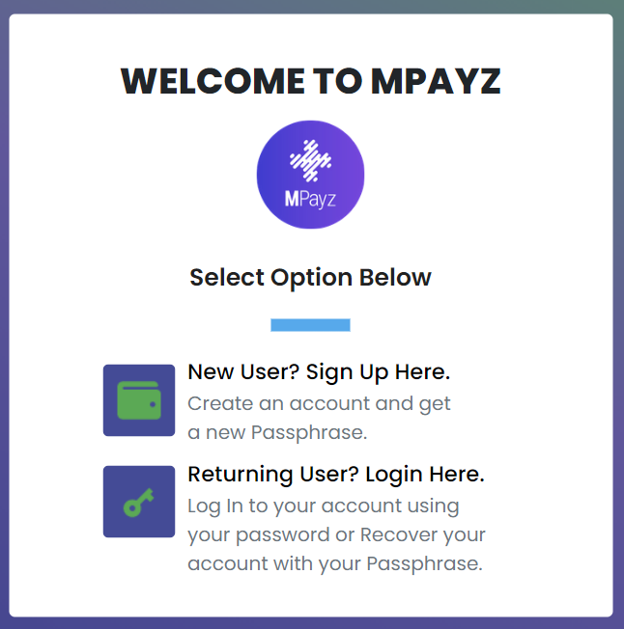

1. **New User? Sign Up Here -** You can use this to create a new account on the application. You will be required to verify your passphrase and email address.
2. **Returning User? Login Here. -** If you already have an account, you can use this option to login to your account dashboard, and perform the desired actions.

## Wallet Dashboard

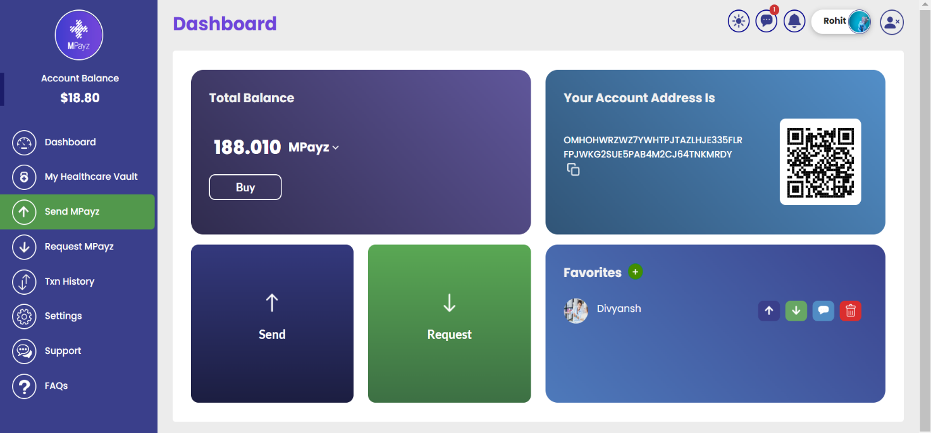

1. **Dashboard**
   1. **Total Balance –** Show your MPayz and Algo balance
   2. **Account Address –** Shows account address hex and qr code.
   3. Shows send & receive to send and receive MPayz tokens.
   4. **Favorites –** You can add contacts for faster access.
2. **My Healthcare Vault -** This is used to create heathcare NFT. Which are eventually used to access medical data. Doctors can scan and login to see the patient medical history. Patients can view there data also.
3. **Send MPayz -** This is used to send MPayz tokens to any other MPayz account. You have to enter destination address, amount needed to be sent, and wallet password. Favourite can be used to set addresses, added as contacts.
4. **Request MPayz -** This is used to request MPayz tokens from any other MPayz account. You have to enter request address, and amount needed to be requested. Favourite can be used to set addresses, added as contacts. Below you can see all the previous requests transaction details.
5. **Txn History -** It shows the details of all the MPayz token and Algo transactions associated with that particular account.
6. **Settings** - It provides you the functionality to change profile name, image and password.
7. **Support -** Chat functionality with support, to resolve any kind of user issue.
8. **FAQs -** List of some frequently asked questions related to MPayz Wallet.

## AdminDashboard

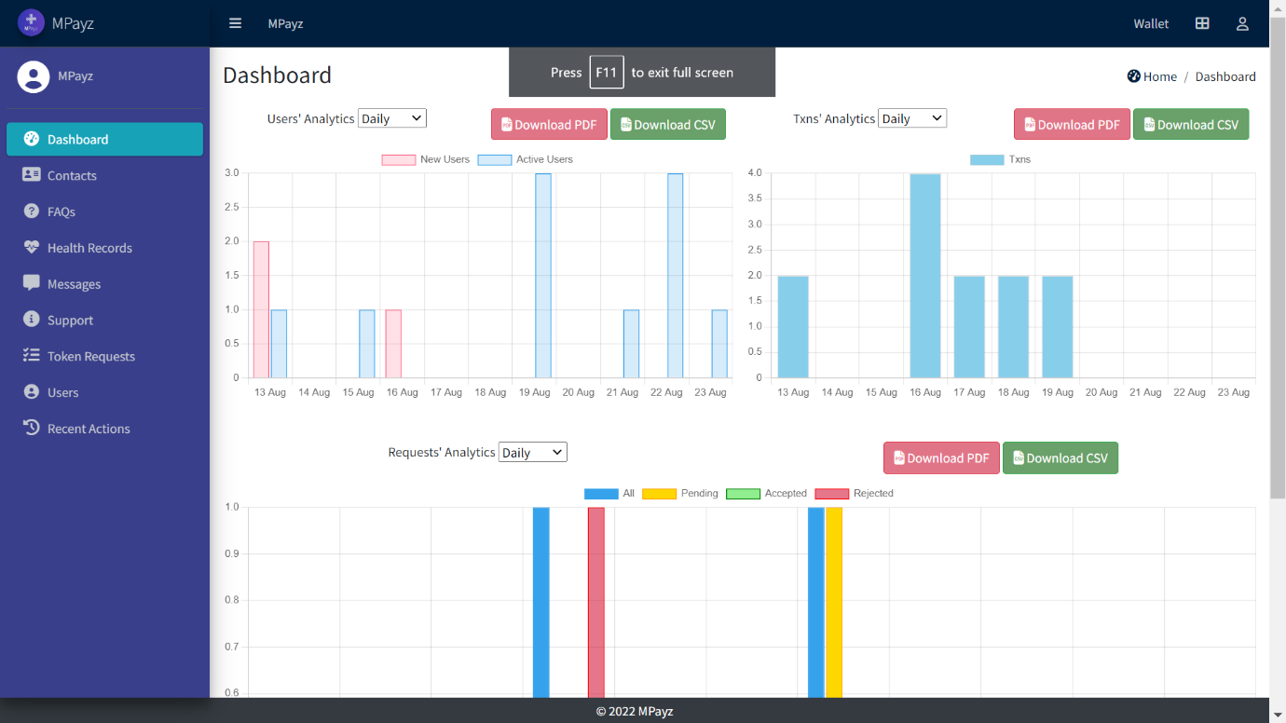

* 1. **Dashboard -** Contains different metrics to know about the application use.
  2. **Contacts -** List of all the favourite contacts added by each of the user. You can perform CRUD operations.
  3. **FAQs -** List of all the FAQs. You can perform CRUD operations.
  4. **Heath Records -** List of NFT details of each user. You can perform CRUD operations.
  5. **Support -** All the chat will support. You can perform CRUD operations.
  6. **Token Requests -** Details of token requests. You can perform CRUD operations.
  7. **Users -** List of all types of users. You can perform CRUD operations, and crowing of permissions.
  8. **Recent Actions -** Log of admin activity